What BEHAVIOR are you trying to change?
____________________________________________________________

What MECHANISM are you trying to change? What underlies change in behavior?
____________________________________________________________

What is the THEORETICAL SUPPORT linking this MECHANISM to this BEHAVIOR?
____________________________________________________________________________________________________________________________________________________________________________________

How will you MEASURE this mechanism? How are you operationalizing this mechanism? Is the measure reliable and valid?
____________________________________________________________

How will you INFLUENCE this mechanism? What intervention will you use?
____________________________________________________________________________________________________________________________________________________________________________________

What is the THEORETICAL SUPPORT linking this INTERVENTION to this MECHANISM/BEHAVIOR?
____________________________________________________________________________________________________________________________________________________________________________________

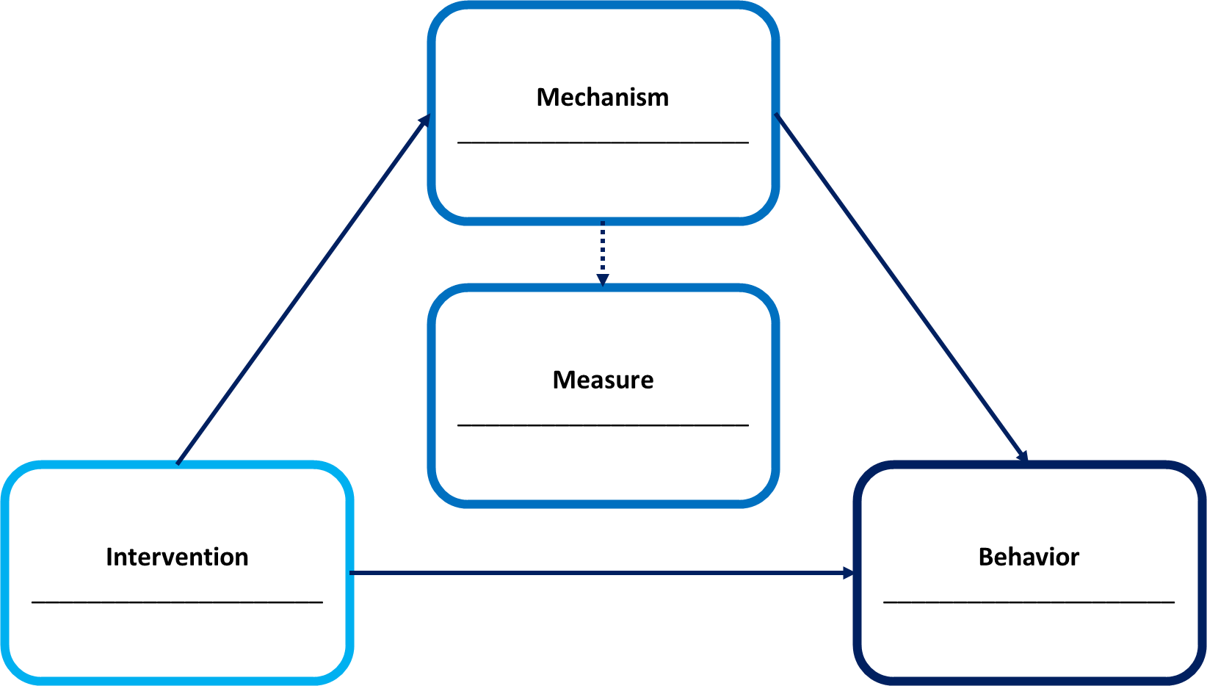

Links:
https://scienceofbehaviorchange.org/
https://measures.scienceofbehaviorchange.org/
https://theoryandtechniquetool.humanbehaviourchange.org/tool

